

Implementation of FCA Integral for KEPL, NOIDA.

|  |  |  |  |  |
| --- | --- | --- | --- | --- |
| **Version** | **1.0** | **Revision** | | **2** |
| **Doc. Author** | Sandeep | | | |
| **Proposal Date** |  | | | |
| **Company Contact** | **Escape Systems Consultants Pvt. Ltd.** | | | |
| #502, Fifth Floor, Time House, Wazirpur Commercial Complex | | | |
| Wazirpur, Delhi - 110054, India | | | |
| Phone | | 011-42475501-04 | |
| Fax | |  | |
| E Mail :akj@fcasoft.com,info@softvizard.com | | | |
| Website : www.FCAIntegral.com | | | |
| **Contact Persons** | Sandeep/Anand | | | |
| +91-9999942423, +91-9811176759 | | | |

This Document is developed as a Proposal for Khokhar Electricals (P)Ltd for Development, Deployment and Implementation of FCA Integral ERP Solution.This is a Controlled Document with limited release only. This Document is submitted by sandeep with full corporate power vested in him on behalf of Escape Systems Consultants Pvt. Ltd.

2012

20/10/2012



1. **Introduction**



KEPL is one of the leading manufacturers of Custom Built Low Voltage Panel Boards and HVAC products in India. Founded in 1985 after acquiring 30 years experience in this field with a clear vision in mind to promote a leading company having its own standing in the electrical field.   
  
KEPL is ISO 9001-2000 accredited for design & manufacture L.T. Electrical Panels, Electric Hot Water Generators, Duct Heaters and Humidifier. KEPL is your reliable partner in empowering your infrastructure. Our projects stand testimony to the fact that KEPL delivers quality solutions.

1. **Requirement Scope:**

The Management Group at KEPL wants to implement an integrated solution giving them the complete picture of the organization related to Finance, Inventory, Sales & Marketing, Purchase, HR & Payroll at the click of a mouse button on as and when required .

The basic aim of this project would be to manage Finance, Inventory, Sales & Marketing, Purchase, HR & Payroll related activities.

All these departments are required to have an integrated approach through a user friendly and affordable solution which could have a set of robust features meeting KEPL Current set of business needs and also support its future expansions. The major requirements of KEPL is described below

1. Pre Sales Activities Like Enquiry Management, Sales Proposal, Cost Sheet.

2.    Inventory Management - Artical Definition, Material Requisition Planning, Ware House Management, Price Management .

3.    Financial Accounting - Expenses, Budgets,Accounts Receivable, Accounts Payable, Cash and Bank.

4.    Sales - Order Management, Sales Invoicing.

5.    Procurement - Requisition, Purchase orders, MRN, Purchase Invoice.

6.    Production - Order based Material Issue at WIP, Production Stage Tracking based on Landmarks Defined.

7.    Quality Management - Quality Forms for Raw material and Production outputs.

8.    Dash Board.

9.    Document Approval through DFD.

10.  HR and Payroll Management.

KEPL Manage their business operations from two locations - one office at Noida and another office at Kirti Nagar. Both the offices required to be integrated and all relevent information / reports will be available at both locations. The Implementation centre shall be Noida office of KEPL

It is also required that the access of solution should be available at mobile laptops to key management personels and RDC solution were proposed for the same.

1. **Architecture**
   1. **Overall Technical Architecture Diagram**

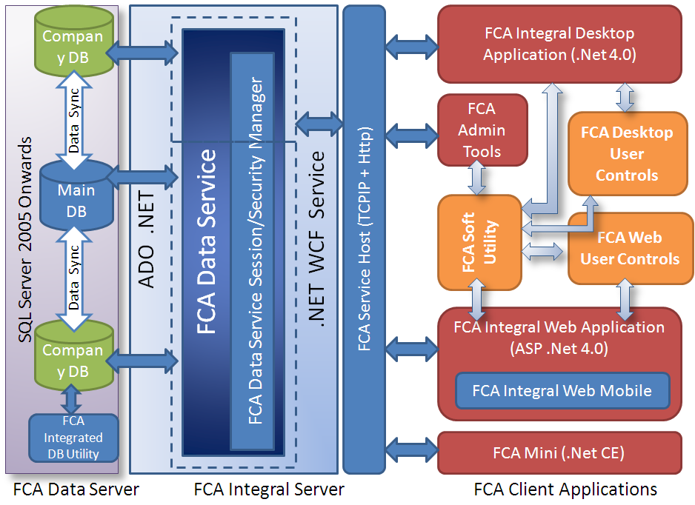

1. **Hardware Requirement**

4.1 FCA: Main Server

Processor: 2x XEON DUAL CORE 1.6 GHZ onward

Operating System: Microsoft Windows Server 2003 Std onward.

Database: MSSQL 2005 STD

Hardware Resources:

Hard disk space: System partition 4GB

Data Partition 40GB

RAM: 8 GB

4.2 FCA: Branch Server

Processor: 2x XEON DUAL CORE 1.6 GHZ Onward

Operating System: Microsoft Windows Server 2003 Std onward.

Database: MSSQL 2005 STD

Hardware Resources:

Hard disk space: System partition 2GB

Data Partition 20GB

RAM: 8 GB

4.3 FCA: Workstation

Processor: 1x Intel Pentium IV

Operating System: Microsoft Windows XP Professional

Hardware Resources:

Hard disk space: About 1 GB free space

RAM: 2GB RAM

The Hardware requirements Given are based on estimated operations and users based on discussions. May need to be upgraded based on performance.

1. **FCA Integral Solution**
   1. **COMMON FEATURES**
   2. **FCA Integral Mobile**

Mobile technology has the potencial to play a key part in meeting an organization's strategic aim. FCAIntegral Mobile is separate application fully integrated with FCA Integral ERP designed to meet the demand and expectation of users with greater efficiencies. The Windows 7.0 based Mobile Application provides option to work both in online and offline mode.

The Application modules includes Beat Plan, Sales Invoice, Order Booking, Collection, Leave Application, Expense claim submission, Stock Taking, Kiosk picture updating etc.

The mobile environment creates several opportunities for organization

* Reach New Customer and Improve Customer Loyalty through time effective actions
* Drive down operational cost
* Improve Decision, Quality and speed up delivery
  1. **FCA Integral HHD**

FCA Integral HHD is Mobile POS Machine solution with on spot billing and invoice generation, Cash Receipt and Cheque Receipt Generation, Payment Collection. The application support Barcode scanning, Credit card swaping, Prints generation and Picture collection.



* 1. **FCA Integral Web**

FCA Integral Web create integration of organization across their Business Partner and Employees. These are Web Based module providing access to Business Partners & Employees of organization to relevet information with highly secured environment. FCA Integral Web includes

* **Customer Collaboration Module**

Customer can access their account statement, TDS Statement, Order and Delivery Status, Raise Order

* **Vendor Collaboration Module**

Vendor can track payment status, Submit supply, services Invoice,

* **Employee Self Service Module**

Emploee can Check leave balances, apply new leave, check leave approval status, submit expense claim form, check claim approval status, print pay slips etc.

* **User Custom requirement Module**

1. **Phase wise Deliverables**

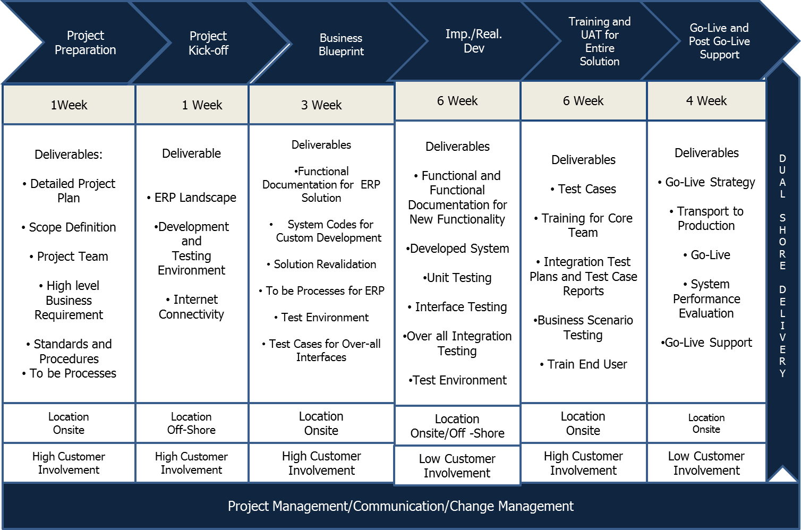

* 1. **Project Timelines:** The detail timelines will be proposed for implementation based on next discussions. A detailed project plan shall be developed during the project preparation phase. Overall elapsed time will be in the range of 11 weeks.



* 1. **Resources Required:** It is estimated that the total effort will be in the range of 210 Man-Days or Person Days. There will be 5 consultants from FCA Integral in the project team and a Project Leader/Manager, total Team Strength from FCA Integral will be 6 Consultants. In addition, the team will consistently need support from KEPL team. The key support required will be in area of reviews, test data creation, user acceptance testing. Following Resources will be deployed during the Project
* Project Manager
* Senior Consultant- Functional (Sr.Implementation Executive)
* Senior Consultant-Technical (.Net Developer)
* Consultant-Functional - (Implementation Executive)



* 1. **Phase wise Roles and Responsibility**
     1. **Project preparation**

This also defines clear project objectives and an efficient decision-making process. Here Project Organization and roles are defined and implementation scope is reevaluated. Baseline Scope is finalized by the end of Business Blueprint and exact requirements defined at the end after Business Blueprint.

|  |  |  |
| --- | --- | --- |
| **Deliverables** | **Responsibility** | **Location** |
| Project Charter | FCA Integral / KEPL | Onsite/Off-Shore |
| Project Plan | FCA Integral / KEPL | Off-shore |
| Revalidation of Project Scope | FCA Integral / KEPL | Onsite |
| Project Team Organization | FCA Integral / KEPL | Onsite/Off-shore |
| Standards & Procedures | FCA Integral | Onsite |
| Broad Functional Scope/requirement Gathering | FCA Integral | Onsite |
| System Landscape Document | KEPL | Onsite |
| Business Baseline Scoping | FCA Integral | Onsite |
| To-Be Processes | FCA Integral / KEPL | Onsite |

The different phases for FCA Integral solution along with the responsibility are listed below.

* + 1. **Project Kick-Off**

In this phase the Project Kick off takes place. The system Connectivity, VPN Access, User Id is given to the development team.

|  |  |  |
| --- | --- | --- |
| **Deliverables** | **Responsibility** | **Location** |
| Project Kickoff Meeting | FCA Integral / KEPL | On site |
| VPN Connectivity | KEPL | Offshore |
| User Id’s with relevant Authorizations | KEPL | Offshore |
| FCA Integral Landscape | KEPL | Offshore |
| Development & Testing Environment | KEPL | Offshore |

* + 1. **Blueprint**

High level Design and Solution Components are designed. Interfaces between various Solution Components are also designed.

|  |  |  |
| --- | --- | --- |
| **Deliverables** | **Responsibility** | **Location** |
| Gap Analysis with the Deployment | FCA Integral / KEPL | On site |
| Requirement Gathering | FCA Integral / KEPL | On-site / Offshore |
| Solution Re-Validation | KEPL | Offshore |
| Blueprint preparation | FCA Integral | Offshore |
| Blueprint sign-off | KEPL | On site |

* + 1. **Realization and Implementation & Development**

In this Phase core Solution Development takes place and Codes are verified and validated. Technical Specification Document are defined in this phase and core development is carried out based on the blueprint. Test Plan is drawn for Code Testing/Unit Testing/Integration Testing and Regression Testing. In this phase the source code with the relevant mapping is put in the customer system. The customer gets a feel of the Solution.

|  |  |  |
| --- | --- | --- |
| **Deliverables** | **Responsibility** | **Location** |
| Technical Specification Document for New Functionality and Interfaces | FCA Integral | Offshore |
| System Codes | FCA Integral | Offshore |
| Code Testing and Unit Testing | FCA Integral | Offshore |
| Tested Codes for Interfaces | FCA Integral | Offshore |
| Overall System Test Plan | FCA Integral | Offshore |
| Testing Environment | KEPL/FCA Integral | Offshore |
| Source Code Deployment | FCA Integral | Offshore |
| Mapping with correct Movement Types | FCA Integral / KEPL | Offshore |
| Solution Validation | KEPL | Offshore |

* + 1. **Training & User Acceptance Testing**

The purpose of this phase is to involve the training of the core team member and End Users of the FCA

Netweaver Portal for CFA/Dealer/Customer Solution to test the Usability of the Application.

**Phase Deliverables**

|  |  |  |
| --- | --- | --- |
| **Deliverables** | **Responsibility** | **Location** |
| Test Cases | KEPL | Offshore |
| Training Core Team | FCA Integral | Onsite |
| Integration Test Plans and Test Cases reports | FCA Integral / KEPL | Offshore |
| System Tests and Integration Test Reports | FCA Integral / KEPL | Offshore |
| Business Scenario Testing | FCA Integral / KEPL | Offshore |
| Train End Users | KEPL | Offshore |
| UAT | KEPL | Onsite / Offshore |

* + 1. **Go-Live & Post Go-Live Support**

This phase is concerned with supporting and optimizing the operative FCA IntegralSolution.

**Phase Deliverables**

|  |  |  |
| --- | --- | --- |
| **Deliverables** | **Responsibility** | **Location** |
| Developing a Final Go-Live Strategy | FCA Integral /KEPL | On-site |
| Go Live | FCA Integral / KEPL | Onsite |
| System performance Evaluation | FCA Integral /KEPL | Offshore |
| Post Deployment Support | FCA Integral | Offshore |

1. X
2. **Assumptions**

* FCA Integral would follow the FCA recommended AFCA methodology for the above implementation.
* FCA Integral requires a lead time of 15 days to kick start the project from the date of the acceptance of the engagement from KEPL
* Change Management/ Business Process Change tasks that need to be done in KEPL as a result of this engagement is not in scope for FCA Integral. This would be managed by KEPL
* The System Test Plan and the Acceptance Criteria would have to be defined jointly by KEPL and FCA Integral during the Conference Room Pilot Workshop.
* KEPL should provide necessary authorization and access to the systems as required by FCA Integral during the engagement.
* KEPL would ensure the correct representation from all groups in the Due Diligence and the Blue Printing workshops so that all requirements and concerns can be addressed correctly.
* Any change to the scope agreed at the end of the Blue printing phase will have to be addressed by a Change Management process and would result in a revision of estimates , timelines and cost.
* KEPL key users and management will be available on a timely basis to participate in the completion of the Business Blueprint.
* KEPL will endeavor the availability of their staff as per the project plan for this assignment. In case of any difficulty client will inform about the non-availability of the particular person in advance. The Steering Committee will evaluate the impact of any core team replacement on the project schedule and cost.
* FCA Integral will provide training only to the core team at the implementation site, end user training will be taken care of the core team members of KEPL
* Any data cleansing or data cleanup in legacy systems is wholly the responsibility of KEPL
* KEPL will use the software, documentation and all the other information for their own internal purposes and will not market or make any other commercial use of the same.
* KEPL and FCA Integral will not offer employment directly or otherwise to each other’s staff for a period of one year from completion of this project.
* The approach is based on the information available to FCA Integral and its understanding of the requirement. Any change in the information or the perceived scope will require changes to this approach.
* FCA Integral shall provide consulting services as per pre-defined project plan.
* Any Software, Hardware or additional licenses that need to be purchased for this engagement would be KEPL responsibility.
* KEPL will provide necessary and adequate infrastructure to FCA Integral On-site staff including office space, telephone, telex, photocopying, fax, PC resources, unlimited access to internet, computer resources, software tools essential to the implementation of the project, to enable FCA Integral to fulfill its commitment to the assignment (none of these facilities will be used for personal work). This will be applicable for each FCA Integral on-site consultant associated with the project.
* KEPL key users and management will be available on a timely basis to participate in the completion of the Business Blueprint.
* KEPL will endeavor the availability of their staff as per the project plan for this assignment. In case of any difficulty client will inform about the non-availability of the particular person in advance. The Steering Committee will evaluate the impact of any core team replacement on the project schedule and cost.
* All milestone deliverables will be deemed acceptable within a period of one week (5 working days) for submission of deliverable in case of no response. Any other decision / approval / sign-off will be deemed acceptable within a period of 3 working days from submission in case of no response.
* FCA Integral will have full rights to change the members of their project team. However FCA Integral will give prior intimation to KEPL and will ensure required continuity and skills profile.

1. **Operating Principles**

FCA Integral agrees with the spirit of the operating principles defined under the scope of work and would like to make the following observations:

FCA Integral is pleased to manage the project with KEPL to ensure that required ERP Solution is developed successfully and as per the business needs and requirements of KEPL FCA Integral follows the philosophy of Knowledge Transfer from the consulting team to the other team that enables the user team to build adequate in-house skills that will enable them to take up the rollout assignments. FCA Integral will follow the same principles with KEPL on this project.

* 1. **Resource Deployment;** The resource deployment has been done keeping in mind the starting and ending of different functionality under different phases and other integration points. This is to ensure that optimal resource is deployed on the project.
  2. **Documentation:** It is expected that prior to commencement of the project, KEPL team shall compile and document all the business processes based on which the modeling and configuration of FCA Integral Solution will be carried out. This shall reduce the time frame for BPD compilation and sign-off, which is critical to the timelines of the current project.
  3. **Team Training:** FCA Integral recommends the suitable training programs for the KEPL Customer Project Team members post go live. There could be a possibility that with a member of the customer can closely work during the development phase.

* 1. **End user training:** The training to end-users shall be conducted and delivered by KEPL team.
  2. **Post Go Live Support and Warranty:** FCA Integral’s Consulting team will provide 1 month (as necessary) post go-live support with one resource.

1. **PROJECT MANAGEMENT**

The Project Management team would be responsible for:

* 1. **Project Co-ordination:** This would involve co-ordination and leading the project team and reporting back to the Project Monitoring Group (Steering Committee). They would be the points of contact for KEPL for purposes of all products, implementation and training support during the implementation. They will also be responsible for the resolution of inter functional issues and conflicts and raise appropriate matters to the attention of the Steering Committee as and when necessary. They will also obtain sign-off on all project deliverables. The KEPL Project Manager will sanction approval for release of payments for the project.
  2. **Project Monitoring:** This involves compliance with the project plan and the provision of early notifications of overruns. The team would be responsible for all the deliverables and assure their quality. The team would be responsible for organizing necessary resources for the project, as and when necessary.

1. **QUALITY MANAGEMENT**

**FCA Integral Quality Policy**

“FCA Integral will continuously strive to delight customers with efficient technological solutions; through evolving and maturing processes and the total involvement of its professionals, partners and customers.” Ensuring the best quality of delivery to our customers is a way of life at FCA Integral and we take several quality initiatives to ensure that the best and most maintainable configuration is “always” delivered to the customer.

* 1. **Project Quality Controls:** We follow specific Quality control practices at each stage of AFCA methodology and maintain following reports, procedures and documents in our FCA assignments:
  2. **Documentation and Quality**
* **Blueprint**
* **Functional Specification Document**
* Technical Design Document
* Component Test Plan
* Program and Deliverables Sign off document
* Field Mappings and Flow Logic
* Naming Conventions, Program Standards and Programming Standards documents

1. **Risk Management**

FCA Integral has identified various risk factors associated with this assignment and understands the impact of these risk factors on the project schedules. Various risks, which could arise during the project, are tabulated below along with a mitigation plan. These risks and mitigation plans shall be reviewed in the weekly report

FCA Integral Project Management team shall continually review the risks associated with the project and continually take steps to mitigate them

| **#** | **Identified risk** | **Impact H/M/L/NA** | **Probability H/M/L** | **Risk Mitigation** | **Risk Avoidance** |
| --- | --- | --- | --- | --- | --- |
| 1 | Scope disagreement / Scope creep | (M)edium | (L)ow | Detailed definition of scope provided in the proposal. Any clarifications will be addressed during the Project Preparation phase. | FCA Integral and KEPL shall follow agreed scope change management procedures |
| 2 | Availability of KEPL SME resources | (H)igh | (H)igh | Identify and communicate inputs required at the beginning of the Project preparation phase. | FCA Integral and KEPL would jointly agree on the SME availability and Publish SME availability calendar at the beginning of the Preparation phase |
| 3 | Business requirements are not fully captured during the Blueprint phase | (M)edium | (M)edium | Functional specifications for the various module Functions and Reports will be signed off at the end of the blueprint phase | FCA Integral and KEPL would agree on the Acceptance Criteria of the Deliverables during Project Preparation phase |
| 4 | Challenges in resource deployment | (M)edium | (M)edium | FCA Integral would proactively identify suitable resources and initiate the visa process |  |
| 5 | Delay in Deliverables sign-off | (M)edium | (M)edium | KEPL Project Manager, Business Analysts, key business users should review and sign-off the deliverables within the accepted timeframe. | FCA Integral will escalate to KEPL management for delays in deliverables review and sign off |

* 1. **Risk Mitigation Process**

With FCA Integral’s experience in International Projects we are familiar with risks in large projects, these risks can be of various natures like users’ resistance to switch from legacy, scope creep, management commitment, organization readiness, change management, staff attrition and so on. FCA Integral has a Proactive methodology for mitigating risks during the implementation cycle. Through our Risk Management practice, we do the followings

* Ensure total participation and commitment from top Management from the very beginning
* Involvement of key business users full time through-out the implementation cycle
* Execute an effective communications strategy that conveys the business benefits not only to select super users but to the whole enterprise
* Routing any deviations from Business Blueprint (i.e. change requests”) through the Project Steering Committee for approvals, and using FCA AFCA Methodology Change Request processes for quality and systematic processing of the approved change requests
* Continuous interaction with the executive sponsors to ensure that adequate customer resources continue to be dedicated to the MES Implementation and Development program despite contention from other projects that might be running concurrently in the customer organization
  + 1. **FCA Integral Risk Management Process**

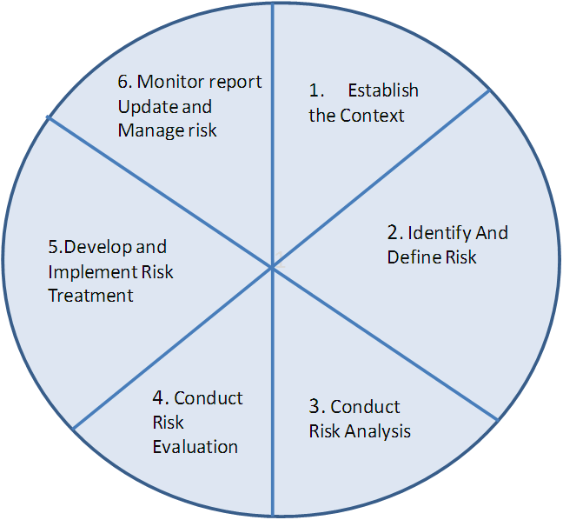

* + 1. **Establish the context.** Define and identify the organization and project environments, characteristics, dependencies and stakeholders, their goals and objectives, and the scope and boundaries of the specific risk management process. Develop criteria against which risks are evaluated and identify the structure for risk management. Ensure all assumptions are recorded in the Assumptions List. When the context has been established then the Risk Management Plan can be prepared.
    2. **Identify and define risks**. The project’s risks are best identified through a collaborative approach involving a wide cross section of stakeholders in the project and recorded in the project’s Risk Register. At the start of each project phase, the risks associated with that phase are formally identified through a similar process. All conceivable risks, including ‘show stoppers’, must be considered. Ensure any certainties are identified as problems and addressed in the project processes.

* + 1. **Conduct risk analysis**. An analysis of the risks is conducted to determine their causes, and estimate their probability and consequences.
    2. **Conduct risk evaluation**. The risks are considered and prioritized according to their potential impact on the business and the project, and each risk is assessed to determine its level of acceptability. The Risk Register is updated with the outcomes of the risk analysis and assessment process and identifies the risks that require management and assigns owners to them.
    3. **Develop and implement risk treatments**. Risk treatments are developed to cost-effectively reduce, contain and control project risk. Formal risk management reporting mechanisms are also defined.
    4. **Monitor, report, update and manage risks**. As risks change during the project, the risk profile is continuously monitored, reviewed and updated. New risks may be identified as more information becomes available and existing risks may be eliminated through the effectiveness of the risk treatments.

1. **Critical Success Factors**

While the overall responsibility for the Project rests with FCA Integral, the following factors are identified as those, which KEPL will strictly follow and perform in order that the implementation is successful and individual milestones as per the Project plan are delivered:

Clear documentation of all processes to be included for implementation as per scope defined, with standardization and uniformity across different units. The initial document shall be compiled by KEPL team based on the existing systems, which shall be used as the basis for further implementation. This shall be completed prior to the commencement date of this project.

Clear definition of Project deliverables and adherence to Project Timelines, Scope and Work Breakdown Structures KEPL will provide full time project team members from both the user department and the IT Department as per the Organization Structure outlined in the Project Organization. The same shall be finalized and approved by the FCA Integral Project Manager and KEPL Project Manager prior to the start of the Project.

* KEPL will provide for suitable hardware, operating system, communication software and all software products to enable effective configuration of Warehouse Management Solution software, as per the mutually agreed schedules.
* KEPL will also provide for a dedicated Phone Line, fax and photo copying machines and suitable office infrastructure for the project team. All such infrastructure facilities will be provided well in time for use in the project effectively.
* KEPL agrees to restrict the software modifications to the minimum. Such modifications are to be approved by both the FCA Integral and KEPL Project Managers in consultation with the Steering Committee, in order to take advantage of the best business practices of FCA and to successfully complete the Project. This is also crucial for a smooth transition with future upgrades
* KEPL is responsible to provide current and accurate data as per the schedules.
* The KEPL Project Manager will give final approval and sign off on all deliverables.
* KEPL agrees for a max 2 days of response times from the time of registering of the input with the concerned personnel.

**Exclusive Use of**

1. **Roles & Responsibilities**
   1. **KEPL Steering Committee:**

The KEPL Publishing Steering Committee makes decisions related to the project that cannot be resolved by the project teams. The Steering Committee would also be responsible for the following:

* Reviewing the progress of the project as per the plan
* Resolving cross-functional issues and policy related issues
  1. **FCA Integral and KEPL Team Structure**
* Project Manager
* Senior Consultant- Functional (Sr.Implementation Executive)
* Senior Consultant-Technical (.Net Developer)
* Consultant-Functional - (Implementation Executive)
  + 1. **FCA Integral team**
       1. **FCA Integral Project Manager:**
* Co-develop and co-manage project plan along with KEPL project manager
* Monitor and report project status
* Ensure project deliverables in terms of scope remain consistent
  + - 1. **FCA Integral Technical and Functional Consultants**
* Gather business requirements on the following subjects:
* Business processes and parameters
* Assist in data transfer mapping
* Determining reporting requirements
* Assist in the development of business process descriptions
* Configure the system based on KEPL requirements
* Provide guidance on the test plan
* Conduct unit tests based on customer defined scenarios
* Conduct implementation & training workshops
* Provide guidance on end user documentation
* Define and implement quality norms

The number of Resources against each skill set is provided in the Section “Effort Estimation”

* 1. **KEPL team**
* Project manager
* Functional expert and end users ( core team)

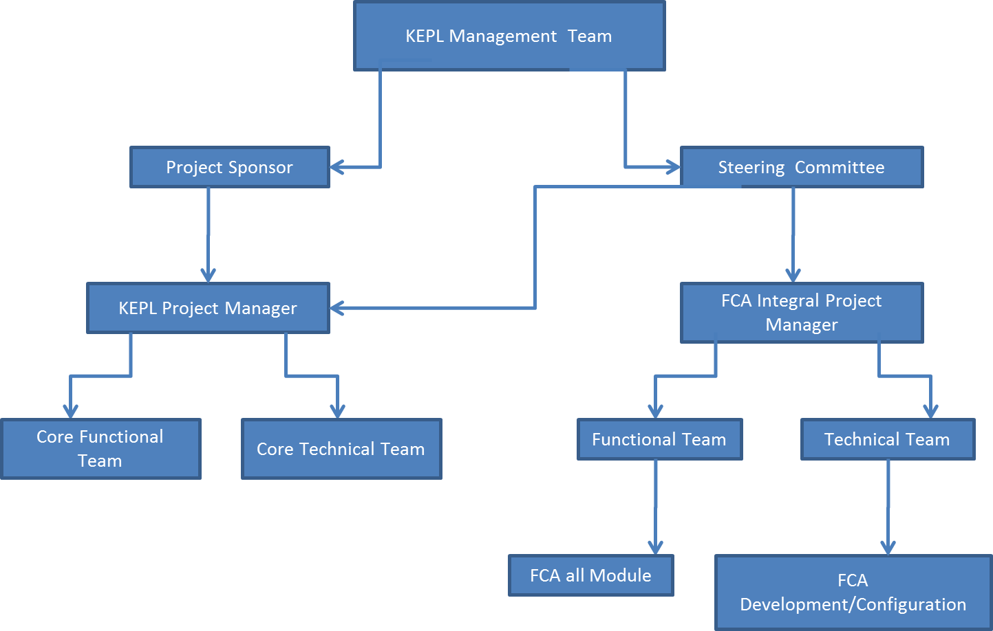

* 1. **FCA Integral commitment:** FCA Integral remain committed in delivering the milestones indicated as part of this project and ensuring successful completion of the stated objectives of this project. FCA Integral will be open to suggestions from KEPL on the performance of the consultants deployed in the project and in the event of unsatisfactory performance of the deployed consultants. FCA Integral will change the consultants to the satisfaction of KEPL KEPL will provide the above mentioned man power on a continuous and uninterrupted basis as and when required by FCA Integral. The FCA Integral team size can go up at different stages in the interest of the project and it will purely at the discretion of FCA Integral. However, FCA Integral will communicate to KEPL the need and the number of additional man power it is deploying and discuss with them.
  2. **KEPL Technical team Training:** It is also proposed that the customer project team is trained on BSP by FCA Integral expert for a week so that the internal team can maintain the application internally.

* 1. **Responsibility Structure:** Overall FCA Integral Project Manager will be responsible for the project delivery. He will work closely with KEPL Project Lead on all the development phases. The KEPL Project Lead is responsible for timely communication of the information required to the FCA Integral PM. He will also be responsible for organizing the UAT and go live activity.

1. **Communication & Account Management**

FCA Integral has clearly defined policies to work closely with customers and adhere to requirements and practices so as to achieve a high level of efficiency during the contract. The ultimate success of our relationship with Client will be measured by the quality of resources provided to Client, compliance to the Client contract, and the complete satisfaction of Client. The policies and practices of FCA Integral are to maintain a healthy and professional relationship with all project personnel, to ensure smooth and successful execution of projects. FCA Integral ensures that all lines of communication are open and there is regular and organized exchange of information. FCA Integral team will collaborate and work with all project team members as part of one large team. In case of any issue or problem, FCA Integral will be proactive and make all efforts to resolve the issue (including involvement of the executive management, if necessary) in resolving any issue or problem. The interests of the project and the client will be of utmost importance.

* 1. **Modes of Communication**

The following modes of communication shall be adopted:

• E-Mail

• Telephonic

• Group Discussion (face-to-face)

• Status Reports

• Issue Log / Database

|  |  |
| --- | --- |
| **Activity/ Event** | **Mode Of Communication** |
| Project Evaluation, Relationship Evaluation, Weekly meeting | Group Discussions, Telephone, E-mail |
| Project Status Meetings | Group Discussions, Telephone, Conference |
| Project Monitoring Through Status Report | E-Mail |
| Disaster Situation in Projects | Conference, Telephone, E-Mail |
| Information Sharing by Project Team | Group Discussions, E-Mail |
| Addressing Issues | E-Mail, Telephone, Issue Log And Database |
| Escalation | E-Mail, Telephone, Conference |

* 1. **Status Reporting**

The success of the project is heavily dependent on the seamless communication mechanism established between the development team and Client. The processes for management, quality assurance, recording and reporting are defined and documented at the start of the project and strictly adhered to. All communication between the offshore team and the Onsite shall be via e-mail, telephone, fax and courier. Project specific communication will typically be via email, conference calls and FTP. In addition to informal communication between the team and Client, regular project progress reports shall be submitted to Client.

The progress report shall contain the following sections:

* Summary of overall progress against schedule
* Work done during reporting period
* Planned work not done during reporting period
* Problems / holdup requiring management action
* Work planned for next reporting period (FCA INTEGRAL)
* Work planned for next reporting period (KEPL)
* List of outstanding actions and actions completed during reporting period
* Measures to be taken to rectify delays and deviations from planned dates
* Administrative and logistic issues
* Work completion certificates and invoices for payment.
  1. **Project Scope Changes**

A change in project scope, schedule, or resources may be initiated by anyone associated with the project.

* The initiator of the change will complete the reason and scope sections of the Change Request Form and sign the “Initiated by”: section. The initiator will then submit the form to the FCA Integral project executive.
* The FCA Integral project executive will collect information about the change, such as the importance (mandatory, desirable, or not critical) and alternate solutions, if any. The impact of the change on budget, schedule, and resources is determined and recorded on the Change Request Form in the project toolkit.
* The FCA Integral project executive will then assign an ID number, and log the requests on the Change Request Summary.
* The FCA Integral project executive will forward the form for review and approval. If a change is mandatory, and has a significant impact on the project, the FCA Integral project executive will convene a meeting of the **Change Control Board** for evaluation and approval.
* The recommendations are sent to the Client for approval.
* Once approved, the FCA Integral project executive will adjust the work plan to accommodate the change.
* No work on any change will be undertaken without *the KEPL* written authorization.
* When the change has been completed, the form will be presented for acceptance of the change.
  1. **Issue Control Procedure**

An issue may be initiated by anyone associated with the project. However, the FCA Integral project executive is responsible for the final decision about how the issue will be resolved. The FCA Integral project executive will be available for explaining the issue and recommending a solution or alternative. Timeliness in resolving issues have an immediate impact on the costs of the project effort.

If an issue is recognized, the initiator completes the Description section of the project toolkit, indicates the criticality of the issue (will or will not cause a delay in the schedule) and presents the form to the FCA Integral project executive. The FCA Integral project executive and the initiator will develop a recommended solution, complete the Approach/Recommendations and Functional Areas Affected sections, and determine the date that a resolution is needed in order to avoid impacting the project schedule and costs. The FCA Integral executive will assign an ID number, log the issue, and present the form for approval. If an open issue needs analysis to correct, a resource will be designated to be responsible for taking the appropriate action. Actions may include initiating discussions, monitoring discussions, determining alternatives, and reaching agreement on a solution.

The FCA Integral project Manager is then notified in writing of the decision, using email.

The FCA Integral project Manager will log the resolution and communicate the results to all interested parties as part of the next status report. If a critical issue remains unresolved after the designated resolution date, the FCA Integral project executive will choose a course of action. If a later resolution is in conflict with the selected action, a change request must be completed. Implementation of the change may affect project costs and schedule.

1. **Commercial Proposal and Effort Estimate**
   1. **Effort Estimate**

|  |  |
| --- | --- |
| **Skill Sets** | **Max Number of Resources** |
| Project Leader | 01 |
| SQL Server 2005 | 01 |
| Senior Consultant (Functional) | 01 |
| Consultant (Functional) | 01 |
| Senior Consultant (Technical) | 01 |

* Elapsed Time : 6 Weeks=77 days
* Working Days: 55 Days
* Skill Sets Required, Including Project Manager : 04 Including Project leader
* Full Time Equivalent : 4 Full Time Equivalent
* Total Man-Days: 165 Excluding 15 Days of Post Implementation/Deployment Support for Bugs, the 15 days support Period for Bugs starts post 15 Days from the Go-Live Date
  1. **Resource Loading**



* 1. **Onsite-Offshore Break-up**



* 1. **License and Implementation Price for FCA Integral Solution**

|  |  |  |  |  |
| --- | --- | --- | --- | --- |
| **S.No** | **Line Item** | **Nos** | **Price** | **Amount** |
| 1.0 | License for FCA Integral Desktop Solution | 20 Users+ 10 Users Free | INR 30,000/= Per User | INR 6.0 Lakhs |
| 2.0 | ADD Ons - License for FCA Integral HR , Admin and Payroll Module | 1 | INR 1,50,000/= | INT 1.5 Lakhs |
| 2.0 | License for FCA Integral Web Solution   * Customer Collaboration Module * Vendor Collaboration Module * Employee Self Services Module | 0 | INR 2,00,000/= (Pack of 200 Con current Users) | INR 0.0 Lakhs |
| 3.0 | License for FCA Integral Mobile Solution | 0 | INR 2,00,000/= (Pack of 20 Mobile Users) | INR 0.0 Lakhs |
| 4.0 | Implementation of FCA Integral Solution | 3 Man Month | INR 90,000/= Per Man Month | INR 2.7 Lakhs |
| 5.0 | Gap Solution development & deployment Support | 2 Manmonth | INR 1,25,000/= Per Man Month | INR 2.5 Lakhs |
| 6.0 | AMC for Licenses for FCA Integral Solution | 20% On License and Customization Cost |  | Free for 12 Months from the Date of Project Start |
|  | **Total** |  |  | **INR 12.7 Lakhs** |

* + 1. **Taxes Extra as Applicable at the time of Billing (Currently 12.36 % Service Tax and 5 % VAT/CST)**
    2. **Payment Schedule for License Price and Implementation Price for FCA Integral Solution - Total- INR 12.7 Lakhs**

|  |  |  |
| --- | --- | --- |
| **Phase** | **Amount in INR** | **Remarks** |
| Advance with Purchase Order (30%) | INR 3.8 Lakhs + Taxes | Essential |
| Completion Of User Acceptance Testing (30%) | INR 3.8 Lakhs +Taxes | Sign-Off by KEPL Project Manager |
| Go-Live (20%) | INR 2.5 Lakhs+Taxes | Sign-Off by KEPL Project Manager |
| Completion of Warranty Period for Bug Fixes (30 Days warranty Support) (20%) | INR 2.6 Lakhs+Taxes | Sign-off from KEPL Puublishing Ltd. Project Manager |
| **TOTAL** | **INR 12.7 Lakhs + Taxes** |  |

1. **Annual Support for Licenses for FCA Integral Solution and only if availed by KEPL**

* 20% of listed (non-negotiated) License Price of “**FCA Integral Solution**”
* The product annual support has the following components:
  + The warranty support for Bug Fixes
  + Free service Pack Enhancements for Current Release
  + New Version Release is not covered and will be Priced Separately
  + INR # Lakhs

1. **Start Date**

The FCA Integral consultant will start the assignment within 15 days from the day after this contract is signed. The project may be started on 4th week of Novemeber 2012 and End on 3rd Week Jan 2012**.** Thiswill include 365 days of Warranty Support for Bug Fixes. But the project plan may be extended because of various circumstances which may be out of control for FCA Integral and KEPL

1. **Budget for Travel/Conveyance/Boarding/Lodging**

* Local Conveyance at the On-site Location: To be taken care by KEPL
* On-site Location Noida and Delhi.

1. **Working Condition for Onsite FCA Integral Consultants**

The consultants assigned to this project by FCA Integral will adhere to the working days and working hours being observed by FCA Integral which is normally 10.00 AM to 7.00 PM as mentioned in the Effort Estimate. It is understood that the consultants may have to work extended hours occasionally. If required by KEPL., the consultants will submit weekly reports to the Project Manager of KEPL FCA Integral Onsite Consultants should be treated at Par with KEPL, Employees during the Onsite Assignment and during FCA Integral Constant’s stay with KEPL., they should be provided with Standard working environment and all Refreshment and Canteen Facility if they are available within the promises of KEPL FCA Integral Consultants should be provided with all necessary infrastructures by KEPL as explained in the Section 5 “Assumptions”

1. **FCA Integral Company Profile and Range of Services**

Over the last 5 years, FCA Integral has acquired leadership status as a global provider of strategic FCA consulting and implementation services, turnkey projects and onsite technical services. FCA Integral builds technological solution to effectively respond to the rapidly changing global business environment. Focused on providing value-added services, our solutions enable customers to:

* Concentrate on their core competencies
* Enhance productivity and value addition
* Reduce costs, risks and implementation time In strategic alliances with world leaders, FCA Integral offers customers complete software solutions, backed by the state-of-the-art technology, while incorporating international business and management practices in its operations.

**Quick Facts about FCA Integral**

* Satisfied clients in 10 Countries and 4 Continents countries
* Having some of the top Fortune SMB 500 companies as clients through Partners
* 12 years in ERP Industry
* Over 60 Employees
* Strong ERP Focus
* Management with 60 Man-Years of ERP Experience